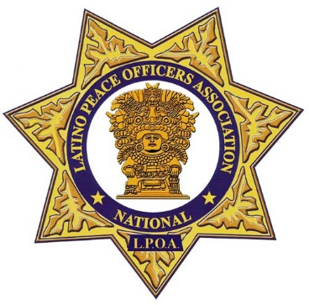
NLPOA FRESNO COUNTY
PO Box 4886
Fresno, CA 93744
www.fresnonlpoa.org

May 26, 2020

Sra. Martiza Garcia
Parlier, CA

Sra. Martiza Garcia y Familia,

Please receive the enclosed Gift Cards from the National Latino Peace Officers Association Fresno County Chapter and members of the community. Enclosed are 3 Gift Cards for a total of $500 to Wal-Mart Stores. We know these are difficult times and we hope this will help you and your family. Please let the children know we support their endeavors and wish them all the best. The following persons / family contributed to the gift card: Ruben & Rosemary Diaz, Joe & Maria Ortiz, Bob & Liz Solis and the NLPOA Fresno County Chapter. Additionally, clothes for the children and adults has been donated on behalf of Rachel Diaz & Raquel Zamorano and Ruben Diaz & Family.

If you have any questions pertaining to these contributions, please feel free to contact me at 559 360-4974 or by email; fivediaz@gmail.com

Best wishes,

Ruben Diaz, President

Cc: Board Members

